## **Silhouette Clustering**

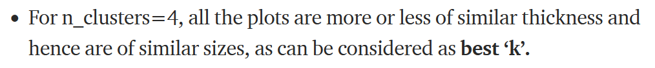

##################################################################################

# **References**

<https://towardsdatascience.com/understanding-k-means-k-means-and-k-medoids-clustering-algorithms-ad9c9fbf47ca>

<https://towardsdatascience.com/silhouette-method-better-than-elbow-method-to-find-optimal-clusters-378d62ff6891>

<https://www.youtube.com/watch?v=DpRPd274-0E>